

**SUPERVISOR’S RECOMMENDATION**

I hereby recommend that the report prepared under my supervision by Amisha Basnet (TU Exam Roll No. 28903/078), Saisa Koirala (TU Exam Roll No. 28932/078), Sandesh Khatiwada (TU Exam Roll No. 28936/078**)** entitled **“AI FOR SKIN DISEASE DETECTION”** in partial fulfillment of the requirements for the degree of B.Sc. in Computer Science and Information Technology be processed for evaluation.

**………………………….**  
**Pawan Niroula**

Lecturer   
Orchid International College  
Bijayachowk, Gaushala



**CERTIFICATE OF APPROVAL**

This is to certify that this project prepared by Amisha Basnet, Saisa Koirala, and Sandesh Khatiwada entitled **“AI FOR SKIN DISEASE DETECTION”** in partial fulfillment of the requirements for the degree of B.Sc. in Computer Science and Information Technology has been well studied. In our opinion, it is satisfactory in scope and quality as a project for the required degree.

|  |  |
| --- | --- |
| **Signature of Supervisor**  **………………………….**  Mr. Pawan Niroula  Lecturer  Supervisor  Orchid International College  Bijayachowk, Gaushala | **Signature of HOD Coordinator**  **………………………….**  Er. Dhiraj Kumar Jha  Head of Department,  Department of IT,  Orchid International College  Bijayachowk, Gaushala |
| **Signature of External Examiner**  **………………………….** | |

**ACKNOWLEDGEMENT**

It is truly a privilege to express our profound gratitude to all those who supported us. We want to express our appreciation to **Er. Dhiraj Kumar Jha** and **Pawan Niroula** for his invaluable assistance in completing this project. His expert guidance and willingness to dedicate time from his busy schedule for project reviews have been instrumental. The continuous inspiration we received from him played a pivotal role in achieving our goals.

Additionally, we would like to extend our sincere thanks to the faculty of Orchid International College, Department of Computer Science and Information Technology, for providing us with this opportunity. Our gratitude also goes to our friends and colleagues for their selfless efforts in aiding us to successfully complete the project.

Amisha Basnet (28903/078)  
Saisa Koirala (28932/078)  
Sandesh Khatiwada (28936/078)

**ABSTRACT**

Skin diseases affect millions worldwide, and timely diagnosis is critical for effective treatment. Traditional diagnostic methods rely on manual visual examination by dermatologists, which can be time-consuming and prone to errors. With the increasing availability of digital skin images, automated detection using artificial intelligence offers a faster and more reliable alternative.

In this project, “AI for Skin Disease Detection,” a system was developed using Convolutional Neural Networks (CNN), MobileNet, and DenseNet121 to classify images into nine common skin disease categories, including Actinic Keratosis, Melanoma, and Atopic Dermatitis. Among the models, DenseNet121 achieved the highest accuracy and was selected as the primary deployed model. The system preprocesses images by resizing and normalizing them, then performs feature extraction and classification using the trained deep learning models.

The dataset was sourced from Kaggle and augmented to improve model generalization. DenseNet121 achieved a final test accuracy of 82%, outperforming CNN and MobileNet models. Confusion matrices and accuracy plots were used to evaluate model performance, confirming reliable classification across all disease categories. This AI-based approach provides a practical and efficient solution for automated skin disease detection, supporting dermatologists in diagnosis and improving patient care.

***Keywords: Skin Disease, Deep Learning, CNN, MobileNet, DenseNet121, Image Classification, DermNet***

**Table of Content**

CHAPTER 1: INTRODUCTION 1

1.1. Problem Statement 1

1.2. Objectives 2

1.3. Scope and Limitations 2

1.4. Development Methodology 2

CHAPTER 2: BACKGROUND AND LITERATURE REVIEW 4

2.1. Background Study 4

2.2. Literature Review 5

CHAPTER 3: SYSTEM ANALYSIS 7

3.1. Requirement Analysis 7

3.1.1. Functional Requirements 7

3.1.2. Non-Functional Requirements 12

3.2. Feasibility Analysis 12

3.3. Object Modeling using Class Diagram 14

CHAPTER 4: SYSTEM DESIGN 16

4.1. Design 16

4.1.1. Sequence Diagram 16

4.1.2. Activity Diagram 17

4.1.3. Component Diagram 18

4.1.4. Deployment Diagram 18

4.1.5. Refinement of Sequence Diagram: 19

4.1.6. Model Architecture 20

4.2. Algorithm Details 20

4.2.1. Convolutional Neural Network (CNN) 20

4.2.2. MobileNetV1 (Transfer Learning) 21

4.2.3. DenseNet121 (Transfer Learning) 21

4.2.4. Model Prediction and Ranking 21

CHAPTER 5: IMPLEMENTATION AND TESTING 22

5.1. Implementation 22

5.1.1. Analysis and Design Tools 22

5.1.2. Implementation Tools (Frontend and Backend) 22

5.1.3. Implementation Details of System Modules 23

5.1.4. Implementation Details of Model 27

5.2. Testing 29

5.2.1. Unit Testing 29

5.2.2. Integration Testing 35

5.2.3. System Testing 36

5.2.4. Model Testing 37

CHAPTER 6: CONCLUSION AND FUTURE RECOMMENDATION 41

6.1. Conclusion 41

6.2. Future Recommendation 41

REFERENCES……………………………………………………………………….43

APPENDIX…………………………………………………………………………..45

**LIST OF FIGURES**

Figure 1.1: Report Organization 3

Figure 3.1: Use Case Diagram for AI For Skin Disease Detection 8

Figure 3.2: Work Breakdown Structure (WBS) of AI for Skin Disease Detection 13

Figure 3.3: Gantt Chart of AI for Skin Disease Detection 14

Figure 3.4: Class Diagram of AI for Skin Disease Detection 15

Figure 4.1: Sequence Diagram of AI for Skin Disease Detection 16

Figure 4.2: Activity Diagram of AI for Skin Disease Detection 18

Figure 4.3: Component Diagram of AI for Skin Disease Detection 18

Figure 4.4: Deployment Diagram of AI for Skin Disease Detection 18

Figure 4.5: Refined Sequence Diagram of AI for Skin Disease Detection 19

Figure 4.6: Model Architecture of AI for Skin Disease Detection 20

Figure 5.1: Registration Module in AI for Skin Disease Detection 24

Figure 5.2: Login Module in AI for Skin Disease Detection 25

Figure 5.3: Image Upload Module in AI for Skin Disease Detection 25

Figure 5.4: Prediction Module in AI for Skin Disease Detection 26

Figure 5.5: View Results Module in AI for Skin Disease Detection 26

Figure 5.6: Unit Testing Scenarios in AI for Skin Disease Detection 35

Figure 5.7: Confusion Matrix of AI for Skin Disease Detection 39

Figure 5.8: Classification Report of AI for Skin Disease Detection 40

**LIST OF TABLES**

Table 3.1: Use Case Description for Register 8

Table 3.2: Use Case Description for Login 9

Table 3.3: Use Case Description for Upload Skin Image 9

Table 3.4: Use Case Description for View Diagnosis Results 10

Table 3.5: Use Case Description for Save Diagnosis Report 10

Table 3.6: Use Case Description for View Past Records 11

Table 3.7: Use Case Description for Logout 11

Table 5.1: User Registration Test Cases 29

Table 5.2: User Login Test Cases 31

Table 5.3: Image Upload Test Cases 32

Table 5.4: Prediction Test Cases 33

Table 5.5: History and Access Control Test Cases 34

Table 5.6: System Test Cases 36

Table 5.7: Model Test Cases 38

# INTRODUCTION

Skin conditions are a widely wide-spread global fitness problem, discovered in individuals of every age. The signs and symptoms, which range from great inclusive of acne and eczema to lifestyles-threatening situations which includes melanoma and psoriasis, are often now not identified or misdiagnosed, specifically in which there are not any dermatology capabilities. Traditional diagnostic techniques are plagued with the aid of human bias and lack of ability to scale.

With advances in Artificial Intelligence (AI) technologies, especially deep gaining knowledge of and picture type, it is now feasible to create structures that are capable of detecting diseases from photos with excessive accuracy. This assignment ambitions to utilize such AI technology the usage of CNN, MobileNet, and DenseNet121 fashions to diagnose dermatological snap shots.

The undertaking is to create a supportive AI product that enables early prognosis, reduces healthcare infrastructure overload, and improves access to care in beneath-resourced areas.

## Problem Statement

Although pores and skin diseases are commonplace, early and correct diagnosis stays a good sized difficulty, specifically in regions wherein experts lack suitable get entry to. Delayed or wrong analysis may additionally lead to critical headaches. Traditional visible diagnosis methods are subjective and unreliable. The venture addresses these issues by means of proposing a deep mastering-based tool to diagnose skin illnesses from dermoscopic pictures for rapid, correct, and low-cost diagnosis.

## Objectives

* To build a deep learning-based classification model for skin diseases using image data.
* To build and train deep learning models (CNN, MobileNet, DenseNet121) for accurate skin disease classification.
* To compare the performance of these models using evaluation metrics such as accuracy, loss, and confusion matrix.
* To deploy the model through a simple web interface for user interaction.

## Scope and Limitations

This venture focuses completely on classifying skin sicknesses using static medical photo facts thru deep learning fashions. It goals to offer early detection and cognizance but excludes real-time diagnostics, external tool integration, and live affected person monitoring. The machine functions as a standalone assistive tool and isn't always a licensed medical diagnostic product. Its effectiveness relies upon on clean photograph input and the exceptional and diversity of the dataset. It is trained in small datasets which maynot accurately predict real word cases perfectly along with the limitation of classification of only 9 diseases.

## Development Methodology

The mission follows an incremental delivery method, dividing improvement into a series of small, attainable iterations. Each generation builds upon the preceding one by using including new functions, permitting non-stop development and versatility. This method suits projects with evolving requirements or high complexity by way of allowing normal remarks and adjustments at some stage in the process. For this task, the preliminary iteration set up core capabilities which includes internet scraping for information collection and fundamental facts processing. Later iterations more advantageous category accuracy and summarization techniques. Each degree become thoroughly examined to make sure reliability before transferring forward. Overall, this technique enabled a bendy, adaptive improvement procedure that efficaciously added a functional and robust gadget.

The record is dependent into six chapters:

* + - 1. Introduction - protecting undertaking evaluate, hassle assertion, targets, scope, constraints, and development technique.
      2. Background Study - reviewing relevant theories, ideas, and comparable works through others.
      3. Analysis - including device necessities and feasibility assessment.
      4. System Design - detailing the overall layout and shape.
      5. Implementation and Testing - describing system used and trying out strategies.
      6. Conclusion and Future Recommendations - summarizing findings and suggesting upgrades.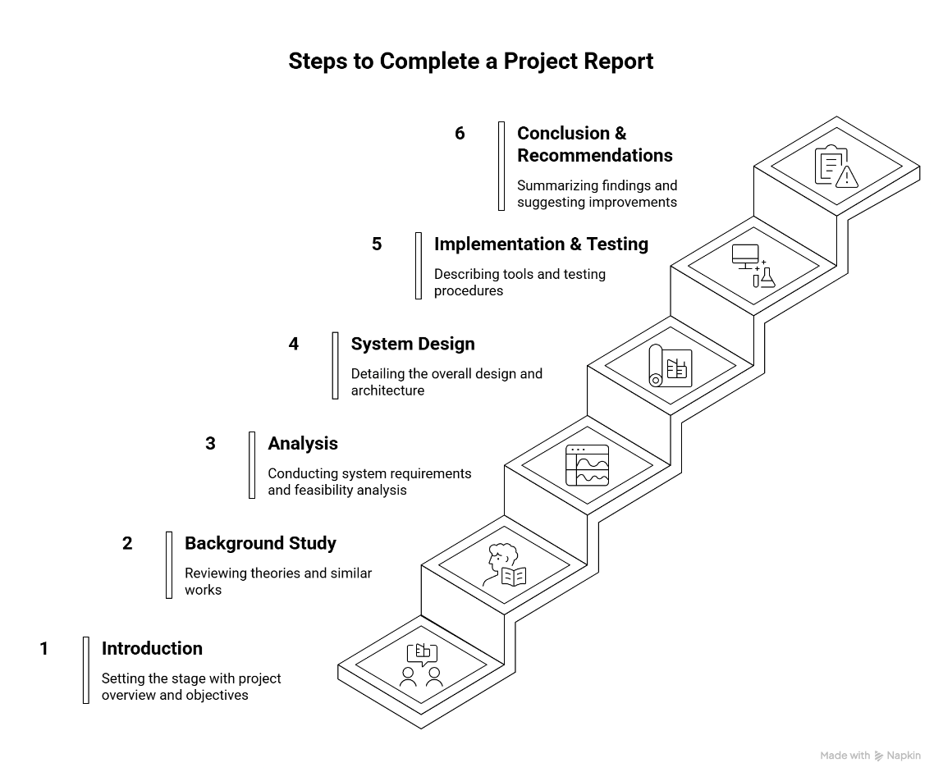

Figure 1.1: Report Organization

# BACKGROUND AND LITERATURE REVIEW

## Background Study

Skin diseases, in particular cancer, retain to pose serious threats to public fitness, specifically in international locations which includes New Zealand, Australia, and the USA, where prevalence rates have substantially risen in latest decades. Melanoma, which arises due to the uncontrolled boom of melanocytes, is one of the deadliest varieties of pores and skin cancer. Early detection of cancer extensively increases survival fees, but accurate prognosis stays tough due to visual similarities among benign and malignant lesions and overlapping features with regular pores and skin.

Traditionally, dermatologists rely on dermoscopic pics and manual evaluation to diagnose skin lesions. However, this procedure needs significant clinical knowledge and is time-eating. In response, computer-aided prognosis systems powered with the aid of Artificial Intelligence (AI) and Machine Learning (ML) have emerged as a promising opportunity to help in early and correct detection.

The advancement of Deep Learning (DL), in particular Convolutional Neural Networks (CNNs), has revolutionized image classification responsibilities. CNNs have shown exceptional fulfillment in recognizing complicated styles in scientific imaging, together with pores and pores and skin lesion category. This method leverages hierarchical characteristic extraction, mimicking the human visual cortex, to successfully look at and distinguish among diverse lesion sorts.

In the research performed through Viswanatha Reddy Allugunti, a deep analyzing-primarily based totally CNN version is developed to categorise varieties of cancer - which consist of lesion maligna, superficial spreading, and nodular cancer. The model achieves excessive classification accuracy (82 %) and outperforms traditional ML algorithms which include Decision Trees, Random Forests, and Gradient Boosted Trees. The studies underscores the potential of CNNs to feature a powerful diagnostic help device, helping clinicians in early cancer detection and treatment making plans.

## Literature Review

Numerous researchers have explored automatic strategies for pores and skin lesion assessment, combining classical device mastering techniques with cutting-edge-day-day deep studying architectures to decorate diagnostic overall performance. These strategies awareness on lesion segmentation, elegance, and longitudinal tracking to aid early most cancers detection and other pores and skin illness identity.

Li and Shen [6] developed a deep learning network for melanoma detection, demonstrating how convolutional neural networks (CNNs) can automatically extract discriminative features from dermoscopic images. Their model achieved high classification accuracy by training on a large number of clinical images and incorporating data augmentation to reduce overfitting.

Kassem et al. [9] carried out switch learning the use of GoogleNet on the ISIC 2019 dataset to categorise 8 particular varieties of pores and skin lesions. Their technique mitigated elegance imbalance by means of the use of best-tuning pretrained weights and normalizing class distributions, engaging in a precision of 94.92% and outperforming different popular architectures like VGG19 and ResNet50. This demonstrates the effectiveness of leveraging pretrained deep networks on smaller, area-precise datasets.

Bi et al. [2] proposed a deep residual community for automated skin lesion evaluation, combining massive-scale dermoscopic datasets with residual connections to beautify gradient float and decrease overfitting. The version correctly segmented and labeled lesions, displaying high overall performance on ISIC datasets, it is important for real-global clinical adoption.

Xie et al. [4] brought a high-decision convolutional neural network for lesion segmentation, focusing on accurate boundary detection. Their technique incorporated multi-scale function maps and refinement layers to deal with versions in lesion size, form, and color. Similarly, Yuan and Lo [3] advanced better convolutional-deconvolutional networks that advanced dermoscopic photograph segmentation, permitting extra unique lesion delineation and helping downstream category tasks.

Rashmi Patil and Bellary [7, 11] focused on stage-wise melanoma classification. They developed specialized loss functions and transfer learning strategies to improve sensitivity and specificity in melanoma detection. Their approach highlighted the importance of stage-based analysis and gradient-based similarity metrics, which enhanced classification performance and clinical interpretability.

Korotkov et al. [8] proposed a lesion matching algorithm for full-body imaging, facilitating longitudinal monitoring of lesion progression. This approach allowed early detection of changes in existing lesions and identification of new suspicious lesions, supporting comprehensive patient evaluation over time.

Ichim and Popescu [10] introduced a dual-stage classifier integrating conditional generative adversarial networks (GANs) and multiple neural networks. By incorporating Total Dermoscopy Score (TDS) into the final classification stage, their system achieved 97.5% accuracy, demonstrating adaptability to different datasets and effective feature fusion from multiple models.

Collectively, those research illustrate a clean trend: the shift from shallow architectures and handcrafted capabilities to deep, residual, and transfer-mastering-primarily based fashions. Combining segmentation and class, regularly with multi-level or ensemble architectures, significantly improves the overall performance of automatic pores and skin sickness detection systems. These improvements not best increase diagnostic accuracy however also offer scalable answers for large-scale scientific and studies programs.

# SYSTEM ANALYSIS

## Requirement Analysis

Requirement analysis is the systematic process of gathering, documenting, and understanding the needs and specifications for a system. For the AI-based Skin Disease Detection System, this step looks on defining project’s objectives, identifying essential features, specifying data requirements, and analysing functional and non-functional requirements.

### Functional Requirements

The functional requirements of the skin disease detection system include:

* + - 1. User Authentication: Secure login and access management for users (patients and medical personnel).
      2. Image Upload: Functionality to upload images of skin lesions from local storage or via webcam.
      3. Disease Classification: Automated prediction of skin disease using a trained AI model (CNN, MobileNet, DenseNet121).
      4. Probability Display: Showing top predicted conditions along with confidence scores.
      5. Visualization: Interactive charts and tables for prediction probabilities and class ranking.
      6. Past Records: Storing and retrieving past uploads and predictions for user reference.
      7. External References: Providing links to reliable information sources for each predicted disease.

The following is the use case diagram that describes different functionalities of the system and interaction between actors:

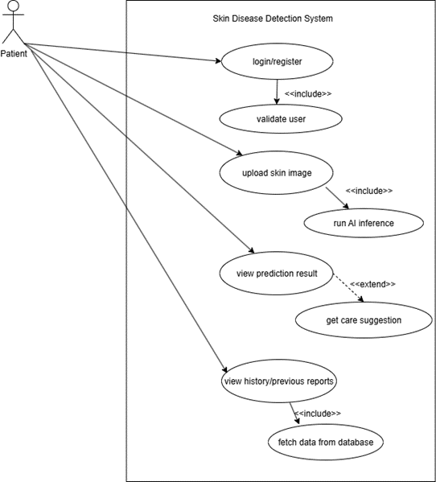

Figure 3.1: Use Case Diagram for AI For Skin Disease Detection

**Use-Case Description:**

Table 3.1: Use Case Description for Register

|  |  |
| --- | --- |
| Use case identifier | UC-01 |
| Use Case Name | Register |
| Primary Actor | User (Patient) |
| Secondary Actor | None |
| Description | Registers a user into the system for secure access. |
| Pre-condition | User has not registered in the system. |
| Success-scenario | User account is created and stored in the database; user can login successfully. |
| Failure-scenario | User is redirected to the registration page again if registration fails. |

Table 3.2: Use Case Description for Login

|  |  |
| --- | --- |
| Use case identifier | UC-02 |
| Use Case Name | Login |
| Primary Actor | User (Patient) |
| Secondary Actor | None |
| Description | Logs the user into the system. |
| Pre-condition | User must be registered. |
| Success-scenario | User is then redirected to the main home page/ dashboard page. |
| Failure-scenario | User is hence redirected to login page again. |

Table 3.3: Use Case Description for Upload Skin Image

|  |  |
| --- | --- |
| Use case identifier | UC03 |
| Use Case Name | Upload Skin Image |
| Primary Actor | User (Patient) |
| Secondary Actor | None |
| Description | User uploads an image of the skin lesion for AI-assisted analysis. |
| Pre-condition | User is logged in. |
| Success-scenario | Image is successfully uploaded and stored in the database. |
| Failure-scenario | User must re-upload image if file format is unsupported. |

Table 3.4: Use Case Description for View Diagnosis Results

|  |  |
| --- | --- |
| Use case identifier | UC04 |
| Use Case Name | View Diagnosis Results |
| Primary Actor | User (Patient) |
| Secondary Actor | None |
| Description | User can view predicted skin disease results after image analysis. |
| Pre-condition | Image has been successfully uploaded. |
| Success-scenario | Predicted results with probabilities are displayed. |
| Failure-scenario | Results fail to generate due to system error. |

Table 3.5: Use Case Description for Save Diagnosis Report

|  |  |
| --- | --- |
| Use case identifier | UC-05 |
| Use Case Name | Save Diagnosis Report |
| Primary Actor | User (Patient) |
| Secondary Actor | None |
| Description | User can save the diagnosis report for future reference. |
| Pre-condition | Diagnosis results are available. |
| Success-scenario | Report is stored in the user’s account. |
| Failure-scenario | Report fails to save due to database error. |

Table 3.6: Use Case Description for View Past Records

|  |  |
| --- | --- |
| Use case identifier | UC-06 |
| Use Case Name | View Past Records |
| Primary Actor | User (Patient) |
| Secondary Actor | None |
| Description | User can view previously uploaded images and diagnosis results. |
| Pre-condition | User is logged in. |
| Success-scenario | All past records are displayed. |
| Failurescenario | No past records found or session expired. |

Table 3.7: Use Case Description for Logout

|  |  |
| --- | --- |
| Use case identifier | UC-07 |
| Use Case Name | Logout |
| Primary Actor | User (Patient) |
| Secondary Actor | None |
| Description | User logs out from the system. |
| Pre-condition | User is logged in. |
| Success-scenario | User is successfully logged out. |
| Failure-scenario | Logout fails due to session error. |

### Non-Functional Requirements

Non-purposeful requirements describe characteristics or attributes of a machine that don't relate to unique behaviors or capabilities but alternatively specify how the system should carry out in terms of characteristics such as performance, usability, security, and reliability. Here are a few non-practical requirements for “AI for Skin Disease Detection”:

1. Security: Secure login with encrypted credential storage.
2. Usability: Simple, intuitive interface for photo upload and end result viewing.
3. Maintainability: Modular codebase for clean updates and retraining.
4. Reliability: Consistent and accurate outputs with information backup mechanisms.
5. Scalability: Ability to handle larger datasets and more diseases in the future.
6. Portability: Deployable across local servers, cloud platforms, and medical institution systems.

## Feasibility Analysis

**Technical**  
On the front-quit aspect, this system runs on a Flask-primarily based internet platform, at the same time as at the again-end facet, deep gaining knowledge of models along with CNN, MobileNet, and DenseNet121 are used with Python. The required development gear (Python, TensorFlow/Keras, Flask, HTML/CSS/JS) are open-source and effortlessly available, making the device technically viable. The running system required is Microsoft Windows or better, which is broadly to be had, making sure compatibility.

**Operational**  
The operational feasibility of the AI for Skin Disease Detection machine is classified to make certain it meets the described goals and presents real-world usability. The gadget offers convenient web-primarily based get entry to, allowing customers to upload pores and skin snap shots and receive predictions thru a consumer-pleasant interface. This makes it practical for each scientific practitioners and widespread users.

**Schedule**  
The venture became divided into a couple of levels, with group contributors accountable for dataset coaching, model education, system integration, and deployment. The challenge turned into planned to be finished inside forty–50 days, which was possible with recognize to time. The time table of the mission is represented through the Work Breakdown Structure (WBS) and Gantt Chart.

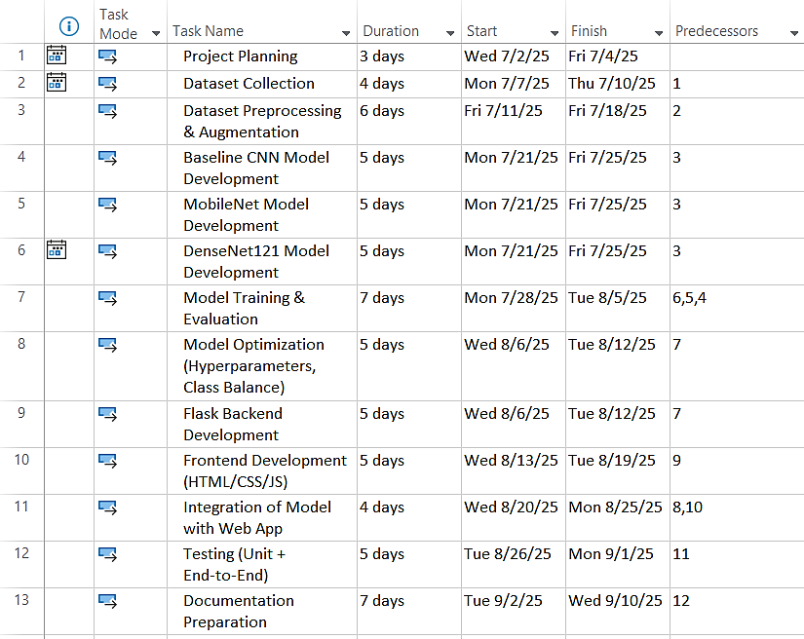

Figure 3.2: Work Breakdown Structure (WBS) of AI for Skin Disease Detection

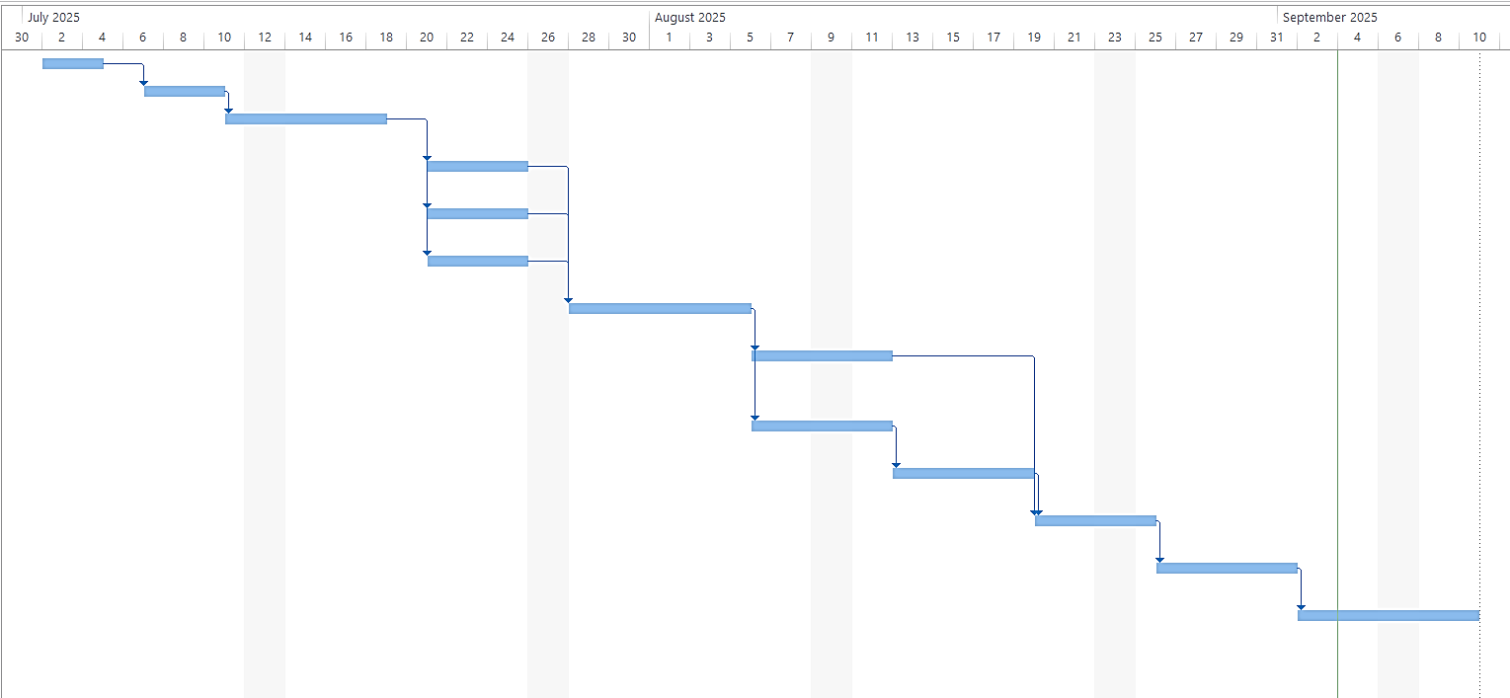

Figure 3.3: Gantt Chart of AI for Skin Disease Detection

* 1. Object Modeling using Class Diagram  
     The class diagram for this AI-Based Skin Disease Detection System carries classes together with User, Image, Prediction, Model, and Disease Information. This diagram serves as a blueprint for the gadget’s object modeling, outlining the important thing instructions, their attributes, functionalities and relationships.
* User: Represents patients or scientific personnel who can check in, login, and think about beyond data.
* Image: Represents uploaded images of skin lesions, storing metadata like add date, image path, and related consumer.
* Prediction: Stores the expected sickness classes, self-belief rankings, and hyperlinks to outside statistics sources.
* Model: Represents the AI models used for type (CNN, MobileNet, DenseNet121), which includes model kind and version.
* Disease Info: Provides additional reference information about illnesses for instructional functions.

The class diagram for the AI-Based Skin Disease Detection System is shown below:

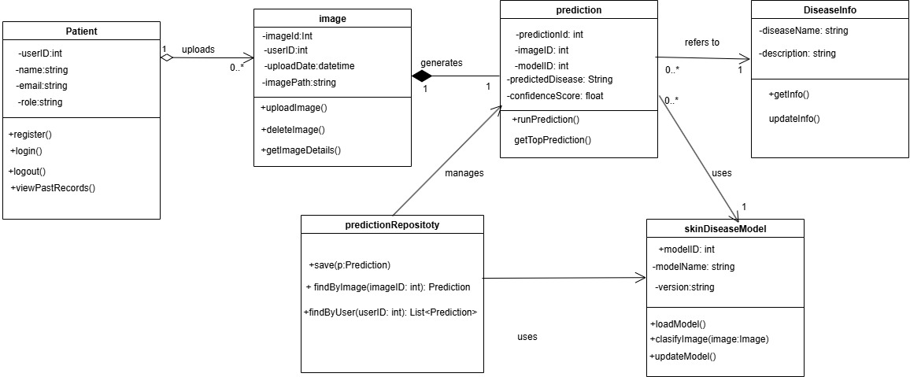

Figure 3.4: Class Diagram of AI for Skin Disease Detection

# SYSTEM DESIGN

## ****4.1. Design****

The gadget layout for the AI for Skin Disease Detection System involves defining its architecture, components, and behavior. This system targets to create a blueprint that courses developers in correctly enforcing the system to fulfill assignment targets of skin disease detection, prediction visualization, and user management.

### ****4.1.1. Sequence Diagram****

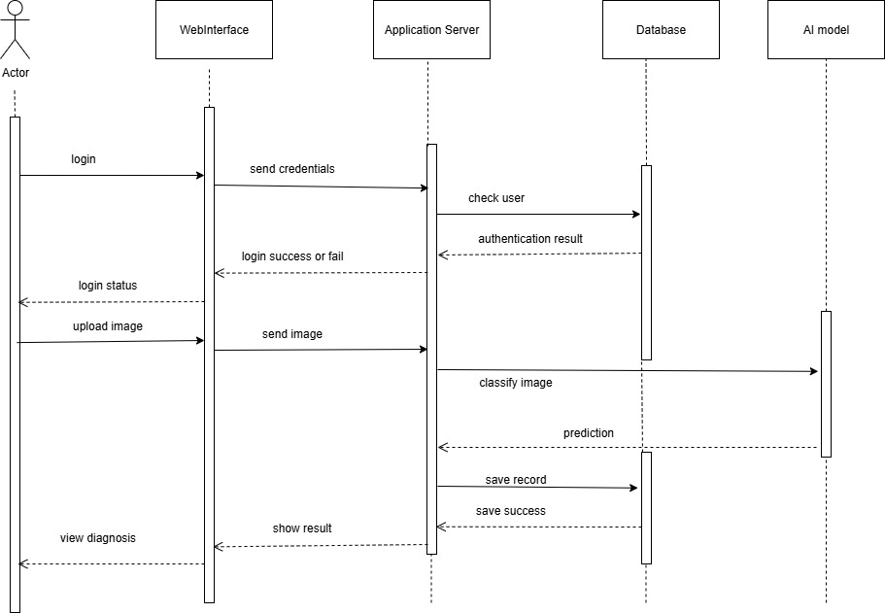

Figure 4.1: Sequence Diagram of AI for Skin Disease Detection

### 4.1.2. Activity Diagram

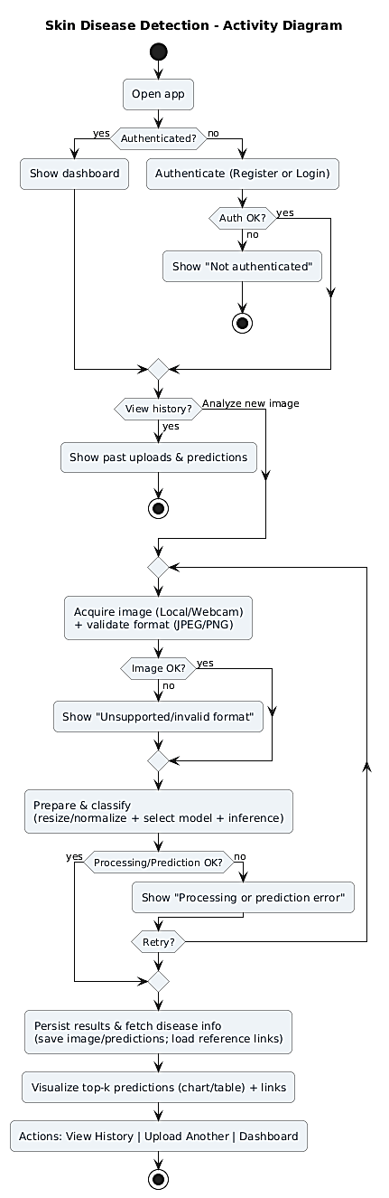

Figure 4.2: Activity Diagram of AI for Skin Disease Detection

### 4.1.3. Component Diagram

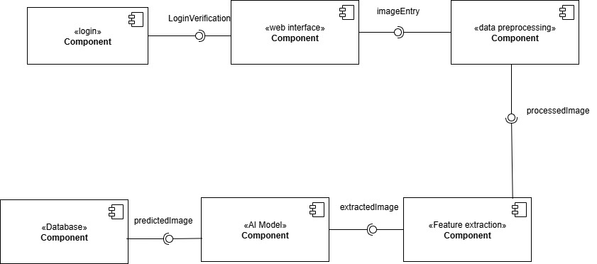

Figure 4.3: Component Diagram of AI for Skin Disease Detection

### 4.1.4. Deployment Diagram

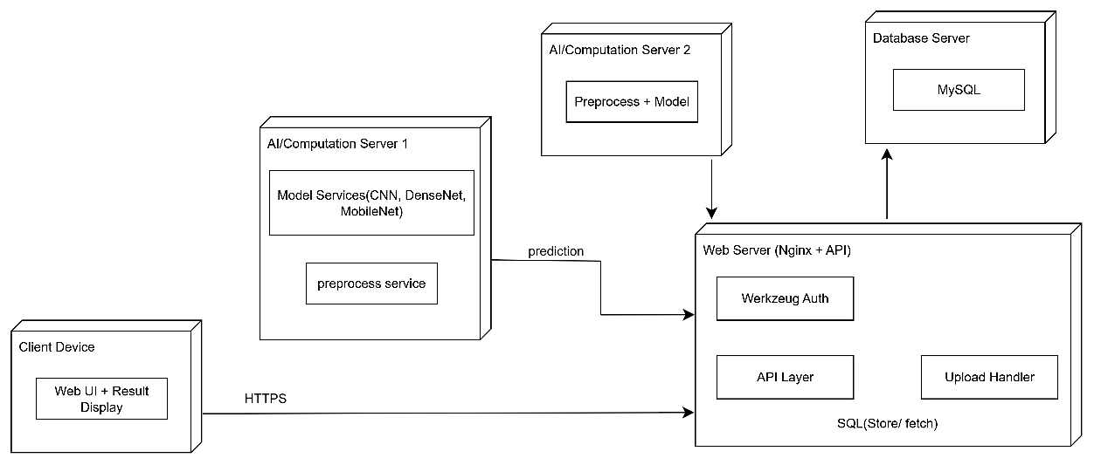

Figure 4.4: Deployment Diagram of AI for Skin Disease Detection

### 4.1.5. Refinement of Sequence Diagram:

A refined sequence diagram provides more refined and better version of sequence diagram which shows the workflow in a project.

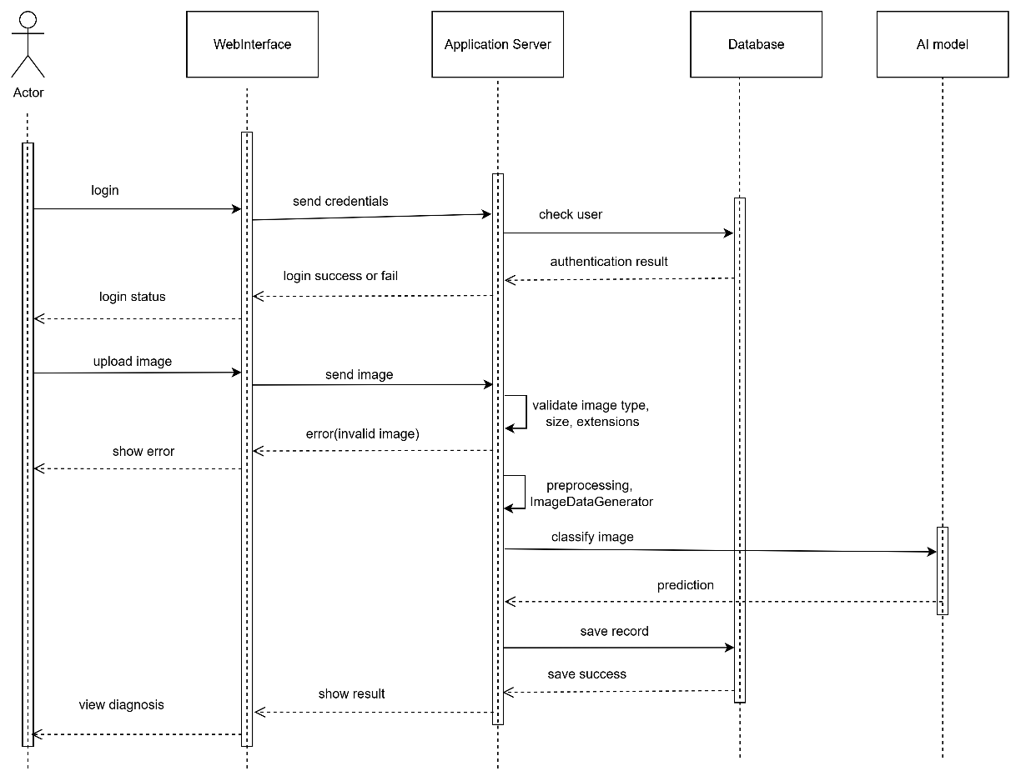

Figure 4.5: Refined Sequence Diagram of AI for Skin Disease Detection

The above refined sequence diagram is same as that of sequence diagram but validates images and preprocesses and enhances it using ImageDataGenerator after login/authentication and uploading image stage is performed. This validation either shows the prediction by classifying image or shows error for image invalidity. Image after prediction is saved and success result is shown.

### 4.1.6. Model Architecture

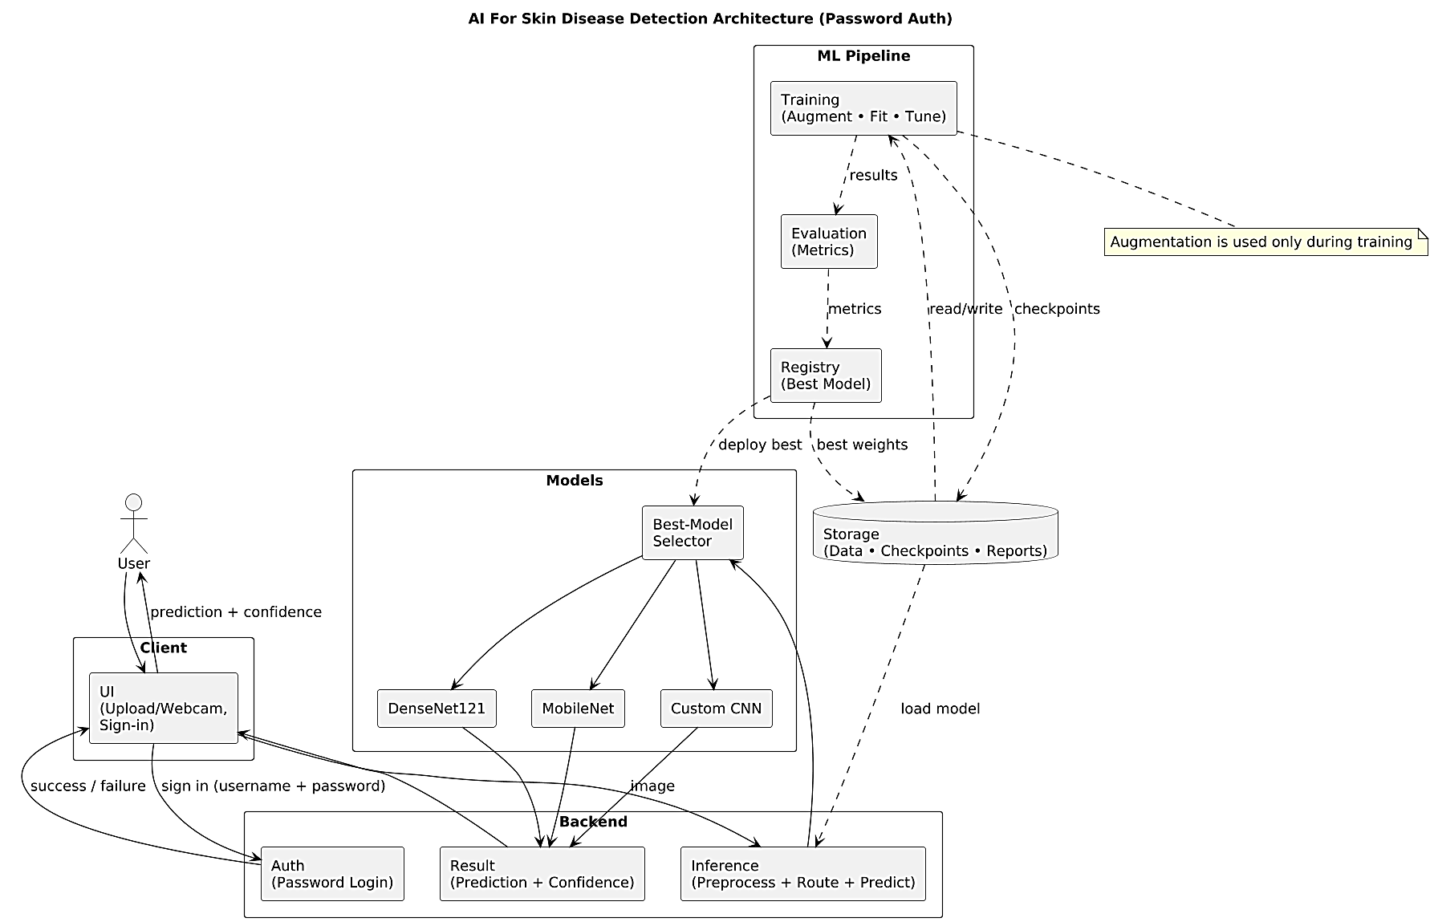

Figure 4.6: Model Architecture of AI for Skin Disease Detection

## ****4.2. Algorithm Details****

### 4.2.1. Convolutional Neural Network (CNN)

* 1. Input Layer: The initial layer where images are fed into the network, which consists of pixel values represented as a multidimensional array.
  2. Convolutional Layers: These layers apply various filters (or kernels) to the input to extract visual features. Each filter produces an activation map, which highlights specific aspects of the input, such as edges or textures. The convolution operation is mathematically defined as:

(x * w) (a) = ∫ x(t) w (a - t)dt

In practical applications, especially in image processing, this is implemented as discrete convolution.

* 1. Activation Functions: Nonlinearities like ReLU (Rectified Linear Units) are employed to introduce non-linear characteristics into the model, enabling it to learn complex patterns. Other common functions include sigmoid and tanh, though they are less frequently used in intermediate layers due to issues like vanishing gradients.
  2. Pooling Layers: These layers are used for downsampling the feature maps, reducing dimensionality, and retaining essential features while discarding less important information. Max pooling is a common technique used here.
  3. Fully Connected Layers: Typically found at the end of the network, these layers convert the high-level features learned by the convolutional layers into output classes. Mathematically, the output is computed as: where W is the weight matrix and b is the bias vector.

FC(x) = f(Wx + b)

* 1. Output Layer: This layer produces the final predictions, often using softmax activation for multi-class classification tasks. [1]

### 4.2.2. MobileNetV1 (Transfer Learning)

* Input: Preprocessed 224×224 RGB pictures.
* Feature Extraction: Uses depthwise separable convolutions for efficient characteristic extraction.
* Pre-trained Weights: Initialized with ImageNet weights for better convergence.
* Fine-tuning: Last few layers are unfrozen to evolve to skin disease dataset.
* Output Layer: Dense layer with Softmax activation for 9 instructions.
* Ranking/Prediction: Returns top predicted skin sicknesses with self-assurance scores.

### 4.2.3. DenseNet121 (Transfer Learning)

* Input: Preprocessed pictures of skin lesions.
* Dense Blocks: This algorithm’s feature solves vanishing gradient by passing current node’s weight to future nodes.
* Transition Layers: Reduce size of feature map along with the complexity among dense blocks.
* Global Average Pooling: Reduces dimensions before absolutely connected layers.
* Fully Connected Layer: Softmax activation outputs chance across trainings.
* Advantage: Improves gradient drift, reduces vanishing gradient hassle, and leverages deep function representations.

### 4.2.4. Model Prediction and Ranking

* Input: New skin lesion image uploaded by user.
* Prediction: Image is passed through CNN/MobileNet/DenseNet models to get class probabilities.
* Probability Display: Top predictions are shown with confidence scores.

# IMPLEMENTATION AND TESTING

## Implementation

### 5.1.1. Analysis and Design Tools

For the AI for Skin Disease Detection project, tools such as draw.io, Microsoft Visio, and Microsoft Project are utilized during analysis and design.

* draw.Io and Visio are employed for developing UML diagrams together with use case, hobby, sequence, and class diagrams to symbolize gadget necessities and workflows. These tools help visualize the architecture, additives, and object interactions inside the device.
* Microsoft Project is used for project making plans and management, along with growing the Work Breakdown Structure (WBS), Gantt charts, scheduling duties, and tracking development.

Together, these tools make sure systematic evaluation, clear layout representation, and powerful mission control in the allotted time frame.

### 5.1.2. Implementation Tools (Frontend and Backend)

#### 5.1.2.1. HTML, CSS, and JavaScript for Frontend

For the frontend of the AI for Skin Disease Detection gadget, HTML and CSS are used to construct the shape and style of the internet application. Forms are designed for image add, and result show pages show prediction consequences. JavaScript is blanketed to provide interactivity and beautify user revel in, such as previewing uploaded snap shots and dealing with basic consumer-aspect validations.

#### 5.1.2.2. Flask Framework for Backend

The backend is advanced the usage of the Flask framework in Python. Flask gives routing, request coping with, and integration with the skilled AI models (CNN, MobileNet, and DenseNet121). The backend handles picture uploads, preprocessing, prediction, and communicates results lower back to the frontend.

#### 5.1.2.3. TensorFlow/Keras for Model Implementation

The educated deep getting to know fashions (CNN, MobileNet, DenseNet121) are carried out using TensorFlow/Keras. These frameworks offer efficient libraries for model definition, education, and inference. The deployed model is optimized for real-time type of pores and skin ailment pictures uploaded by means of customers.

#### 5.1.2.4. Database Management (SQLite/MySQL)

For storing consumer facts and prediction history, a database machine inclusive of MySQL (scalable) is used. It ensures dependable management of person uploads, prediction results, and log records.

#### 5.1.2.5. Diagram Tools

**Draw.io and PLANTUML:** All the UML diagrams used in the project are made with either draw.io or PLANTUML. Draw.io provides easy interface to draw diagrams manually by the use of available shape while PLANTUML draws diagrams on the basis of code provided to it.

**MS-Project:** Gantt chart and Work Breakdown Schedule in the project was made with the use of MS-Project.

### 5.1.3. Implementation Details of System Modules

#### 5.1.3.1. Registration Module

The registration web page is the preliminary interface that lets in new users to enroll in the system. During registration, the password entered with the aid of the consumer is securely hashed the usage of Werkzeug Utilities in Python Flask. The registered user’s statistics, such as login credentials, is then saved inside the database for authentication functions.

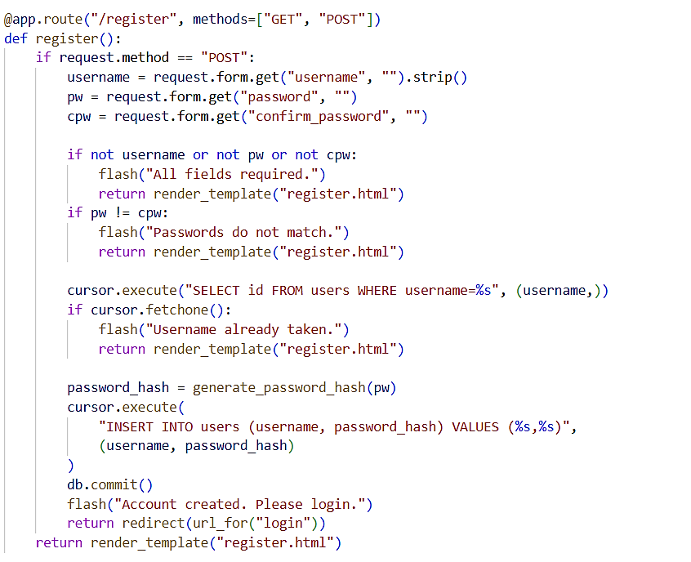

Figure 5.1: Registration Module in AI for Skin Disease Detection

#### 5.1.3.2. Login Module

The login process ensures that most effective registered and authenticated customers can access the gadget. This module requires the username and password, which are confirmed towards the records saved in the database. Upon successful authentication, users are granted access privileges to the machine. Invalid login tries are confined, preserving device safety.

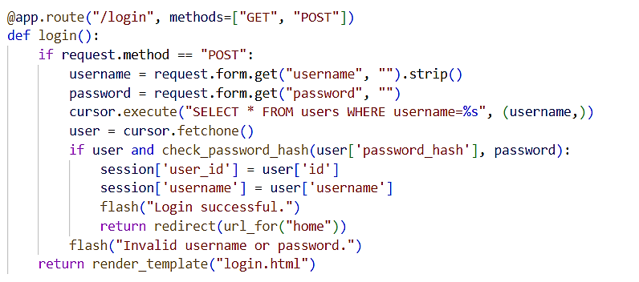

Figure 5.2: Login Module in AI for Skin Disease Detection

#### 5.1.3.3. Image Upload Module

The picture upload module serves as the enter interface where users put up photographs of their skin for evaluation. Uploaded pics are demonstrated to ensure they meet the desired format (e.G., JPG, PNG). The system then forwards the photograph to the AI version for processing. If non-pores and skin pics (e.G., random gadgets) are supplied, the model will no longer produce valid classifications.

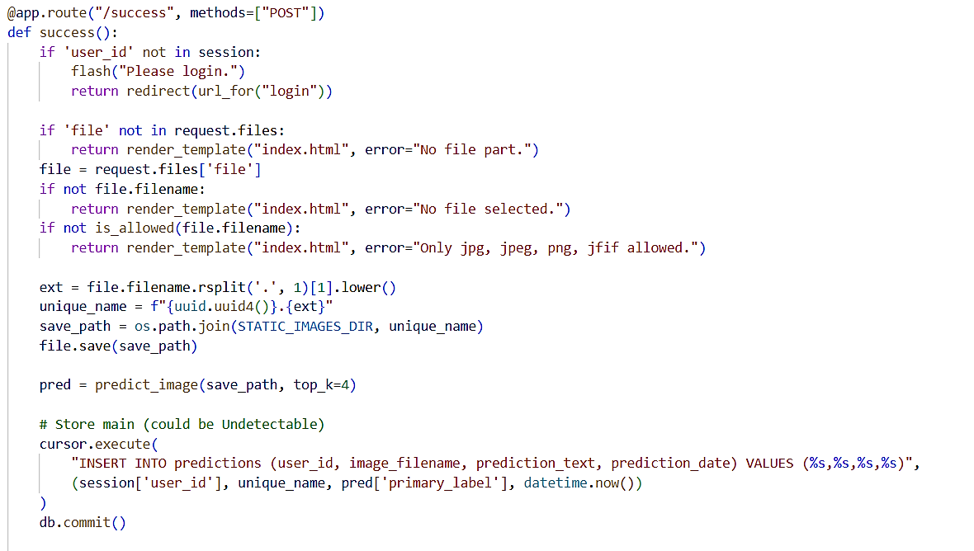

Figure 5.3: Image Upload Module in AI for Skin Disease Detection

#### 5.1.3.4. Prediction Module

The prediction module is the core component of the system. Once the photograph is uploaded and preprocessed, it's far exceeded via the skilled AI model (DenseNet121). The module returns the predicted pores and skin disease together with a self assurance score. Additionally, the gadget affords reference hyperlinks (e.g., Wikipedia or authentic medical sources) to assist customers examine greater about the expected sickness.

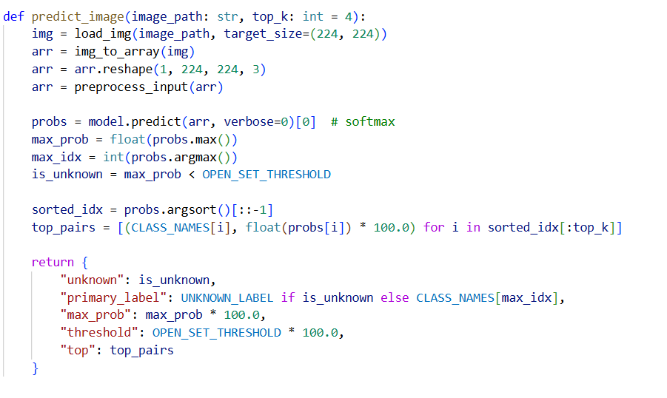

Figure 5.4: Prediction Module in AI for Skin Disease Detection

#### 5.1.3.5. View Results Module

This module shows the prediction results in a clear and person-friendly manner. Users can see their contemporary prediction and also get admission to their beyond prediction history, that's saved inside the database. This function permits customers to study previous uploads and monitor patterns through the years.

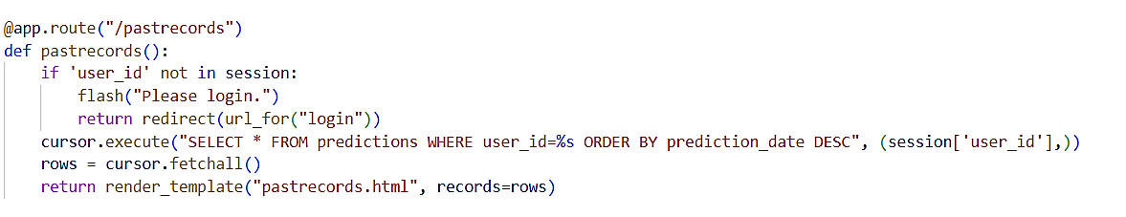

Figure 5.5: View Results Module in AI for Skin Disease Detection

### 5.1.4. Implementation Details of Model

#### 5.1.4.1 Data Collection

A dataset of skin disease images was collected from Kaggle and organized into training, validation, and testing directories in Google Drive.

1. Total Images in the dataset: 900 images
2. Training Sets: 720 images (80% of the total dataset images)
3. Validation and test sets: 180 images (20% of the total dataset images)
4. Number of Disease to predict: 9 Diseases
5. Diseases to Predict:
   * Actinic keratosis
   * Atopic Dermatitis
   * Benign keratosis
   * Dermatofibroma
   * Melanocytic nevus
   * Melanoma
   * Squamous cell carcinoma
   * Tinea Ringworm Candidiasis
   * Vascular lesion

#### 5.1.4.2 Data Preprocessing

5.1.4.2.1. Data Cleaning  
Images were resized to 224×224 pixels, normalized using pixel scaling (rescale=1. /255), and augmented with modifications which includes rotation, moving, zooming, and flipping to increase variability. This step decreased overfitting and stepped forward generalization.

5.1.4.2.2. Exploratory Data Analysis   
EDA included checking the number of images per class and their balance in the dataset. Although some classes had fewer images, class weights were later applied during training to handle imbalance.

5.1.4.2.3. Label Encoding   
Image folder names were automatically encoded into numerical labels by the data generator (flow_from_directory). Each class was assigned an integer label for training and evaluation.

5.1.4.2.4. Feature Extraction   
Instead of hand-crafted features, deep feature extraction was performed using DenseNet121 pretrained on ImageNet. The convolutional layers extracted hierarchical features such as texture, edges, and skin patterns, which were then processed by custom dense layers.

5.1.4.2.5. Data Splitting   
The dataset was split into:

* Training set (80%): Used to educate the model.
* Validation set (10%): Used for hyperparameter tuning and early preventing.
* Testing set (10%): Used for final model evaluation.

#### 5.1.4.3 Model Training

#### The DenseNet121 model was used with pretrained ImageNet weights as the base model.

* The base model was unfrozen, allowing fine-tuning of convolutional layers.
* A Global Average Pooling layer followed by a Dropout (0.4) layer was added to reduce overfitting.
* A Dense softmax output layer classified images into 9 disease categories.
* The version become educated the usage of the Adam optimizer (mastering charge = 1e-4), express crossentropy loss, and sophistication weights to address imbalance.
* EarlyStopping and ReduceLROnPlateau callbacks were used to prevent overfitting and optimize learning.  
  Training was conducted for up to 30 epochs on Colab GPU, with real-time monitoring of training and validation accuracy.

#### 5.1.4.4 Model Evaluation

After training, the model achieved:

* Validation Accuracy: ~80.6%
* Final Test Accuracy: 81.77%  
  Evaluation was done using:
* Confusion Matrix to visualize correct/incorrect classifications per class.
* Classification Report providing precision, recall, and F1-scores for each skin disease category.

#### 5.1.4.5 Model Deployment

All the models were trained and, the best one “DenseNet” was saved as h5 file format for using in flask project.

In deployment:

* Users upload skin lesion images.
* Images undergo preprocessing (resizing, normalization).
* The model predicts disease class and displays probabilities.
* The system also shows a confusion matrix and classification metrics for performance analysis.

## 5.2. Testing

### 5.2.1. Unit Testing

Unit testing for the Skin Disease Detection System involves testing individual components in isolation, including user login, image upload, model prediction, and admin functionality. The following tables present the test cases:

Table 5.1: User Registration Test Cases

|  |  |  |  |  |  |  |
| --- | --- | --- | --- | --- | --- | --- |
| **S.No** | **Description** | **Prerequisite** | **Steps** | **Input** | **Expected Result** | **Actual Result** |
| 1 | Verify user can register with valid data | User is on register page | 1. Enter Username 2. Enter Email 3. Enter Password 4. Confirm Password 5. Click Register | Username amisha Email amisha@gmail.com Password amisha@123 Confirm amisha@123 | User is registered and redirected to login page | User registered and redirected to login page |
| 2 | Verify user cannot register with blank fields | User is on register page | 1. Leave one or few fields empty  2. Click Register | Username:  Email:  Password: | System shows error for missing field | System showed error for missing field |
| 3 | Verify user cannot register with duplicate username | User is on register page and username sandesh already exists | 1. Enter existing Username 2. Enter Email 3. Enter Password 4. Click Register | Username sandesh Email sandesh@gmail.com Password 123 | System shows error username already exists | System showed error username already exists |

Table 5.2: User Login Test Cases

|  |  |  |  |  |  |  |
| --- | --- | --- | --- | --- | --- | --- |
| **S.No** | **Description** | **Prerequisite** | **Steps** | **Input** | **Expected Result** | **Actual Result** |
| 1 | Verify user login with correct credentials for sandesh | User is on login page | 1. Enter Username 2. Enter Password 3. Click Login | Username sandesh Password 123 | User is logged into dashboard | User logged into dashboard |
| 2 | Verify user login with correct credentials for saisa | User is on login page | 1. Enter Username 2. Enter Password 3. Click Login | Username saisa Password saisa@123 | User is logged into dashboard | User logged into dashboard |
| 3 | Verify user login with correct credentials for amisha | User is on login page | 1. Enter Username 2. Enter Password 3. Click Login | Username amisha Password amisha@123 | User is logged into dashboard | User logged into dashboard |
| 4 | Verify user login fails with wrong password | User is on login page | 1. Enter Username 2. Enter wrong Password 3. Click Login | Username amisha Password wrong@123 | System shows error incorrect username or password | System showed error incorrect username or password |
| 5 | Verify user login fails with empty fields | User is on login page | 1. Leave Username empty 2. Leave Password empty 3. Click Login | Username (empty) Password (empty) | User is not logged in and error is shown | User was not logged in and error was shown |

Table 5.3: Image Upload Test Cases

|  |  |  |  |  |  |  |
| --- | --- | --- | --- | --- | --- | --- |
| S.No | Description | Prerequisite | Steps | Input | Expected Result | Actual Result |
| 1 | Verify image upload after login | User is logged in and on upload page | 1. Click Upload 2. Select file 3. Click Submit | File lesion1.jpg | Image is accepted and sent for processing | Image accepted and sent for processing |
| 2 | Verify system rejects invalid file type | User is logged in and on upload page | 1. Click Upload 2. Select file 3. Click Submit | File sample.pdf | System shows error invalid file type | System showed error invalid file type |
| 3 | Verify upload blocked when not logged in | User is not logged in | 1. Open upload page 2. Try to submit file | File lesion2.jpg | System redirects to login page | System redirected to login page |
| 4 | Verify large image is handled | User is logged in and on upload page | 1. Click Upload 2. Select large file 3. Click Submit | File lesion_large.jpg size 12 MB | System shows error file size limit or processes with delay | System showed error file size limit |

Table 5.4: Prediction Test Cases

|  |  |  |  |  |  |  |
| --- | --- | --- | --- | --- | --- | --- |
| S.No | Description | Prerequisite | Steps | Input | Expected Result | Actual Result |
| 1 | Verify prediction for known class | User has uploaded valid image | 1. Click Predict | Image of Actinic keratosis | Model predicts Actinic keratosis with high score | Model predicted Actinic keratosis with high score |
| 2 | Verify prediction for another class | User has uploaded valid image | 1. Click Predict | Image of Melanoma | Model predicts Melanoma with high score | Model predicted Melanoma with high score |
| 3 | Verify prediction with low quality image | User has uploaded low quality image | 1. Click Predict | Blurred image | Model returns best match with lower confidence or low confidence warning | Model returned best match with lower confidence |

Table 5.5: History and Access Control Test Cases

|  |  |  |  |  |  |  |
| --- | --- | --- | --- | --- | --- | --- |
| S.No | Description | Prerequisite | Steps | Input | Expected Result | Actual Result |
| 1 | Verify admin can view prediction history | Admin is logged in | 1. Open Prediction History | None | System shows list of past predictions with time and class | System showed list of past predictions with time and class |
| 2 | Verify access control for history page | User is not admin | 1. Open Prediction History | None | System denies access and shows not allowed message | System denied access and showed not allowed message |
| 3 | Verify user can view own past records | User is logged in | 1. Open My Records | None | System shows user's past uploads and predictions | System showed user's past uploads and predictions |

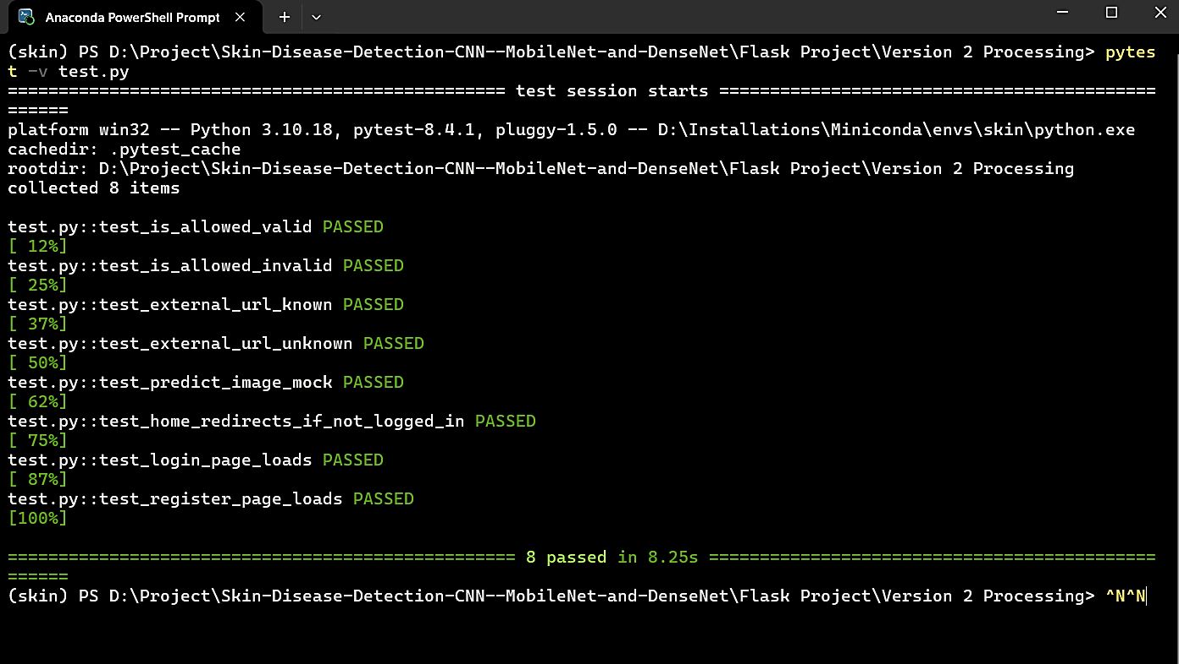

Figure 5.6: Unit Testing Scenarios in AI for Skin Disease Detection

### 5.2.2. Integration Testing

Integration testing for the Skin Disease Detection System ensures smooth interaction between its components - frontend (Flask UI), backend (model inference), and database (user records and history). The test cases verify the integration of image upload, preprocessing, and classification modules.

|  |  |  |  |  |  |  |
| --- | --- | --- | --- | --- | --- | --- |
| **S.No** | **Description** | **Prerequisite** | **Steps** | **Input** | **Expected Result** | **Actual Result** |
| 1 | Verify user image upload and prediction | User is on upload page | 1. Click "Choose File" 2. Select valid image 3. Click "Predict" | Image of Atopic Dermatitis | Model classifies disease and displays result | Model classified image as Atopic Dermatitis |
| 2 | Verify error for unsupported file upload | User is on upload page | 1. Click "Choose File" 2. Select test.docx 3. Click "Predict" | File test.docx | System shows error message "Invalid file format" | System displayed error "Invalid file format" |
| 3 | Verify admin can view uploaded images and prediction logs | Admin is logged in username: sandesh, password: 123 | 1. Go to "View Logs" 2. Check uploaded files list | All uploaded images and predictions should be listed | Admin saw all uploaded images and predictions |  |

### 5.2.3. System Testing

System testing evaluates overall Skin Disease Detection System and ensures that it meets requirements like accuracy, performance, and full functionality.

Table 5.6: System Test Cases

|  |  |  |  |  |  |  |
| --- | --- | --- | --- | --- | --- | --- |
| **S.No** | **Description** | **Prerequisite** | **Steps** | **Input** | **Expected Result** | **Actual Result** |
| 1 | Verify classification of test images | System ready with test dataset | 1. Upload 10 test images | 10 images of various skin diseases | All images classified correctly | 9 out of 10 images classified correctly |
| 2 | Verify performance under multiple uploads | System ready with batch upload | 1. Upload 50 images at once | 50 images uploaded | All images stored and classified quickly | All images stored and classified within expected time |
| 3 | Verify overall functionality | System ready with all features | 1. Register 2. Login 3. Upload image 4. Predict 5. View history | All operations performed | All functionalities should work without error | All functionalities worked as expected |

### 5.2.4. Model Testing

Model testing validates that the trained DenseNet121 and MobileNet models function as expected with accuracy and real-world predictions.

Table 5.7: Model Test Cases

|  |  |  |  |  |  |  |
| --- | --- | --- | --- | --- | --- | --- |
| **S.No** | **Description** | **Prerequisite** | **Steps** | **Input** | **Expected Result** | **Actual Result** |
| 1 | Verify model accuracy | Test dataset available | 1. Evaluate model on test set | 200 images of 9 classes | Model accuracy >70% | Model achieved 71.82% accuracy |
| 2 | Verify confusion matrix balance | Test dataset available | 1. Evaluate model on test set | 200 images across 9 classes | Confusion matrix shows balanced class predictions | Confusion matrix showed slight imbalance but acceptable |
| 3 | Verify prediction for specific image | User uploaded valid image | 1. Click "Predict" | Image of Psoriasis | Model predicts Psoriasis correctly | Model predicted Psoriasis correctly |

Evaluation Metrics for AI for Skin Disease Detection

1. **Confusion Matrix**  
   The confusion matrix presents a detailed breakdown of the version's predictions as opposed to the actual labels across all skin ailment categories. It lets in us to visualise the performance of our class model, highlighting areas of correct and incorrect predictions for every disorder kind.
2. The figure five.3 depicts the confusion matrix, which illustrates the category consequences of our version throughout the 9 skin sickness classes in our AI for Skin Disease Detection machine:

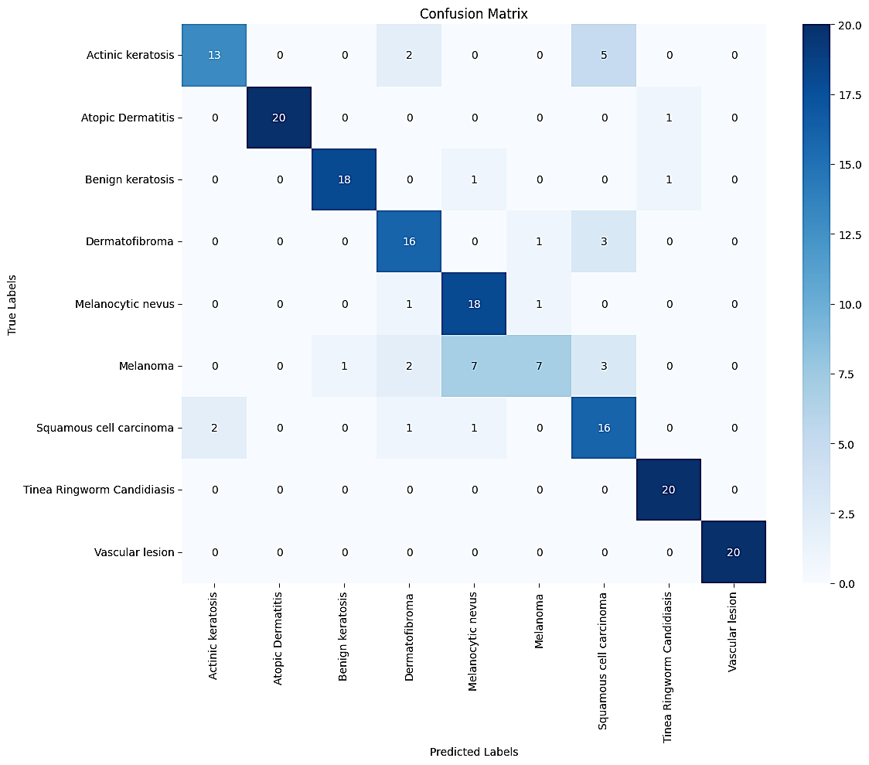

Figure 5.7: Confusion Matrix of AI for Skin Disease Detection

1. **Accuracy**  
   The confusion matrix presents a detailed breakdown of the version's predictions as opposed to the actual labels across all skin ailment categories. It lets in us to visualise the performance of our class model, highlighting areas of correct and incorrect predictions for every disorAccuracy is a fundamental metric that measures the overall correctness of our model's predictions throughout all pores and skin sickness classes. It indicates the percentage of correctly labeled snap shots out of the whole pix evaluated. A better accuracy rating signifies higher normal overall performance of the classification model. Based at the evaluation of our model, the accuracy completed is 82%.
2. **Precision**  
   Precision measures the share of correctly predicted images for a particular ailment class out of all pics expected as belonging to that category. In our context, precision shows the version's potential to appropriately perceive a selected pores and skin disorder, minimizing fake positives.
3. **Recall**  
   Recall assesses the model's potential to capture all images belonging to a selected sickness category out of all pix that clearly belong to that class. It reflects the version's sensitivity in successfully figuring out diseased cases, thereby minimizing fake negatives.
4. **F1-Score**  
   The F1 score provides a balanced evaluation of the model’s overall performance, thinking of both precision and take into account. It offers a complete view of ways nicely our version plays in effectively classifying skin sicknesses. The type record figure beneath provides a detailed review of our model's overall performance, which include precision, keep in mind, F1-score, and support for every pores and skin disease class.

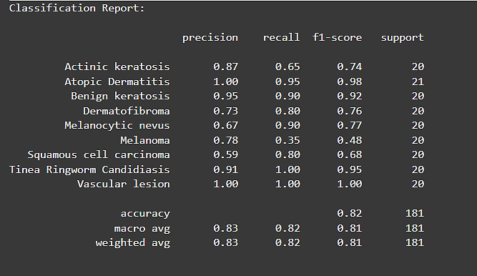

Figure 5.8: Classification Report of AI for Skin Disease Detection

# CONCLUSION AND FUTURE RECOMMENDATION

## Conclusion

In cease, the AI for Skin Disease Detection machine is a complete solution designed to help healthcare professionals and individuals in accurately figuring out various skin diseases through computerized picture assessment. By integrating deep learning algorithms along with DenseNet121, MobileNet, and a custom CNN model, the tool efficiently classifies pores and skin disorder pix and offers dependable diagnostic insights.

Throughout the improvement procedure, cautious attention became given to facts preprocessing, version training, and evaluation, making sure the gadget is powerful and performs properly throughout 9 specific skin sickness categories. Extensive sorting out, together with functionality, accuracy, and model widespread overall performance evaluations, validates the machine's reliability, effectiveness, and value in real-worldwide situations.

Overall, the AI for Skin Disease Detection machine represents a treasured device for boosting early analysis, supporting dermatologists, and empowering customers with on hand pores and skin fitness tracking.s

## Future Recommendation

For similarly enhancement of the AI for Skin Disease Detection system, several pointers can be taken into consideration for future work:

1. Integration of Advanced AI Techniques: Implementing greater sophisticated deep getting to know fashions or ensemble methods may want to enhance classification accuracy and better cope with rare pores and skin disease cases.
2. Continuous Learning from Feedback: Incorporating mechanisms to learn from user remarks or dermatologist input can help the device adapt and enhance over the years.
3. Expansion to Mobile and Real-Time Applications: Developing cellular-primarily based programs with real-time image seize ought to make pores and skin disorder detection more reachable to customers in remote areas.
4. Personalized Health Recommendations: Extending the system to offer personalised treatment tips or preventive care tips based totally on diagnosed conditions ought to add substantial consumer fee.
5. Enhanced Data Privacy and Security: Ensuring stable garage and processing of touchy medical information, at the side of compliance with healthcare regulations, is important for retaining consumer consider.
6. Regular Model Updates: Continuously updating the model with new information and scientific findings will assist the system remain accurate and relevant as pores and skin ailment patterns evolve.

The implementation of these hints can similarly improve the effectiveness, accessibility, and general impact of the AI for Skin Disease Detection device in healthcare.

**REFERENCES**

[1] Zhang Ce, Xin Pan, Huapeng Li, Gardiner A, Sargent I, Jonathon S Hare, et al. A hybrid MLP-CNN classifier for very fine resolution remotely sensed image classification. ISPRS Journal of Photogrammetry and Remote Sensing. 2017;140:133-144.

[2] Bi Lei, Jinman Kim, Euijoon Ahn, Feng D. Automatic Skin Lesion Analysis using Large-scale Dermoscopy Images and Deep Residual Networks. ArXiv abs. 2017;1703:04197.

[3] Yuan Y, Lo YC. Improving Dermoscopic Image Segmentation with Enhanced Convolutional-Deconvolutional Networks. IEEE J Biomed Health Inform. 2019 Mar; 23(2):519-526. DOI: 10.1109/JBHI.2017.2787487.

[4] Feng-ying Xie, Jiawen Yang, Liu J, Zhi-guo Jiang, Yushan Zheng, Yukun Wang. Skin lesion segmentation using high-resolution convolutional neural network. Computer Methods and Programs in Biomedicine. 2020;186:105241.

[5] Yao Y, Luo Z, Li S, Fang T, Quan L. MVSNet: Depth Inference for Unstructured Multi-view Stereo. In: Ferrari V., Hebert M., Sminchisescu C., Weiss Y. (eds) Computer Vision – ECCV 2018. ECCV 2018. Lecture Notes in Computer Science, 2018, 11212. Springer, Cham. Https://doi.Org/10.1007/978-3-030-01237-3_47

[6] Li Y, Shen L. Skin Lesion Analysis towards Melanoma Detection Using Deep Learning Network. Sensors (Basel). 2018 Feb 11;18(2):556. DOI: 10.3390/s18020556. PMID: 29439500; PMCID: PMC5855504.

[7] Rashmi Patil, Sreepathi Bellary. Machine mastering technique in melanoma cancer level detection. Journal of King Saud University - Computer and Information Sciences. 2020;2020. Https://doi.Org/10.1016/j.Jksuci.2020.09.002

[8] Konstantin Korotkov, Josep Quintana, Ricard Campos, América Jesús-Silva, Pablo Iglesias, Susana Puig, et al. An Improved Skin Lesion Matching Scheme in Total Body Photography. IEEE Journal of Biomedical and Health Informatics. 2019 Mar;23(2):586-598.

[9] Kassem MA, Hosny KM, Fouad MM. Skin Lesions Classification into Eight Classes for ISIC 2019 Using Deep Convolutional Neural Network and Transfer Learning. IEEE Access. 2020; 8:114822-114832. DOI: 10.1109/ACCESS.2020.3003890.

[10] Ichim L, Popescu D. Melanoma Detection Using an Objective System Based on Multiple Connected Neural Networks. IEEE Access. 2020; 8:179189-179202. DOI: 10.1109/ACCESS.2020.3028248.

[11] Patil R, Bellary S. Transfer studying based totally system for melanoma type detection. Revue d'Intelligence Artificielle. 2021;35(2):123-a hundred thirty. Https://doi.Org/10.18280/ria.350203

**APPENDIX**

**Screenshots:**

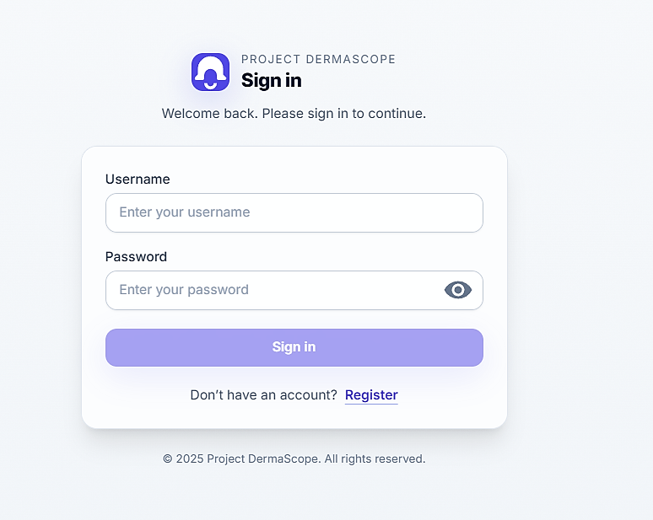

**APPENDIX A Sign in Page**

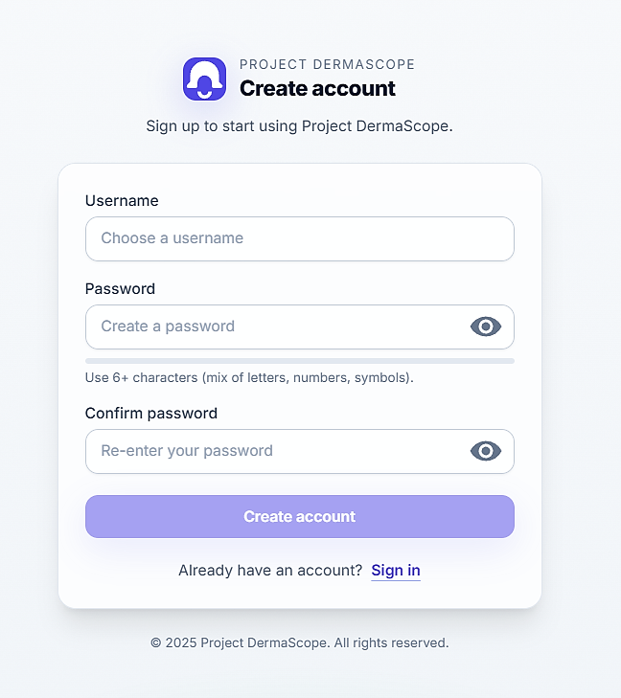

**APPENDIX B Register Page**

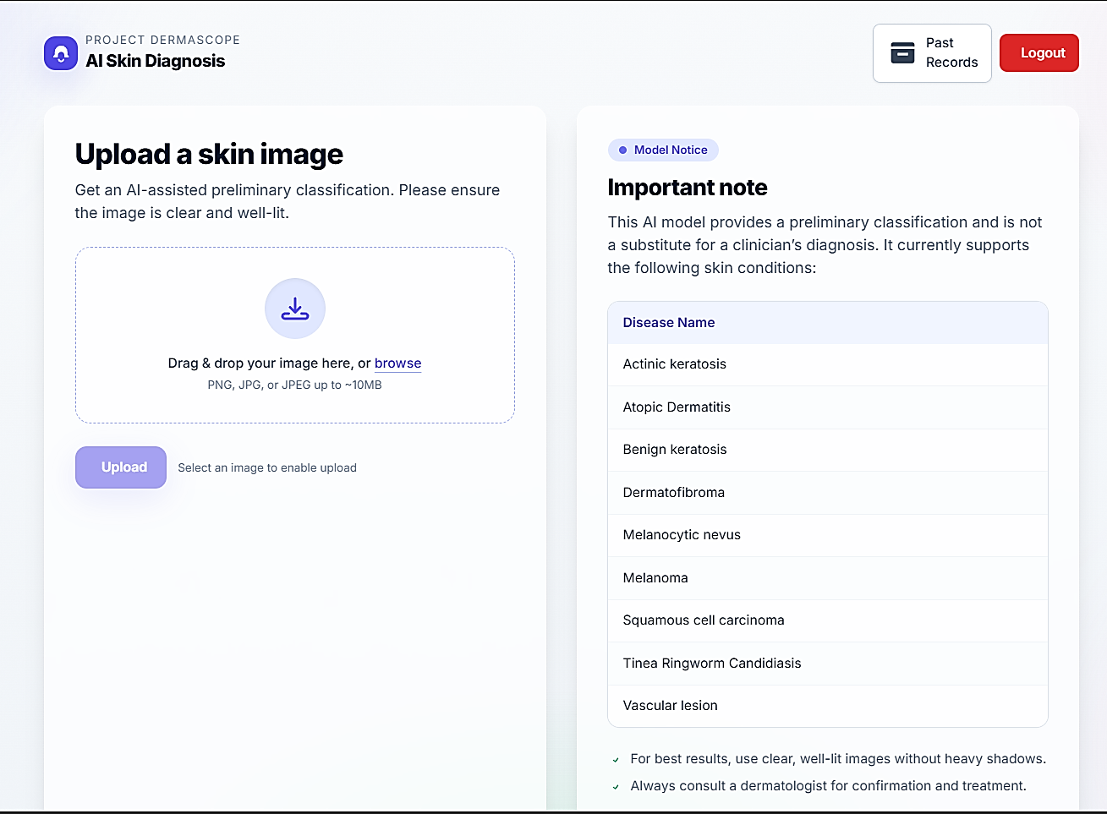

**APPENIX C Home Page**

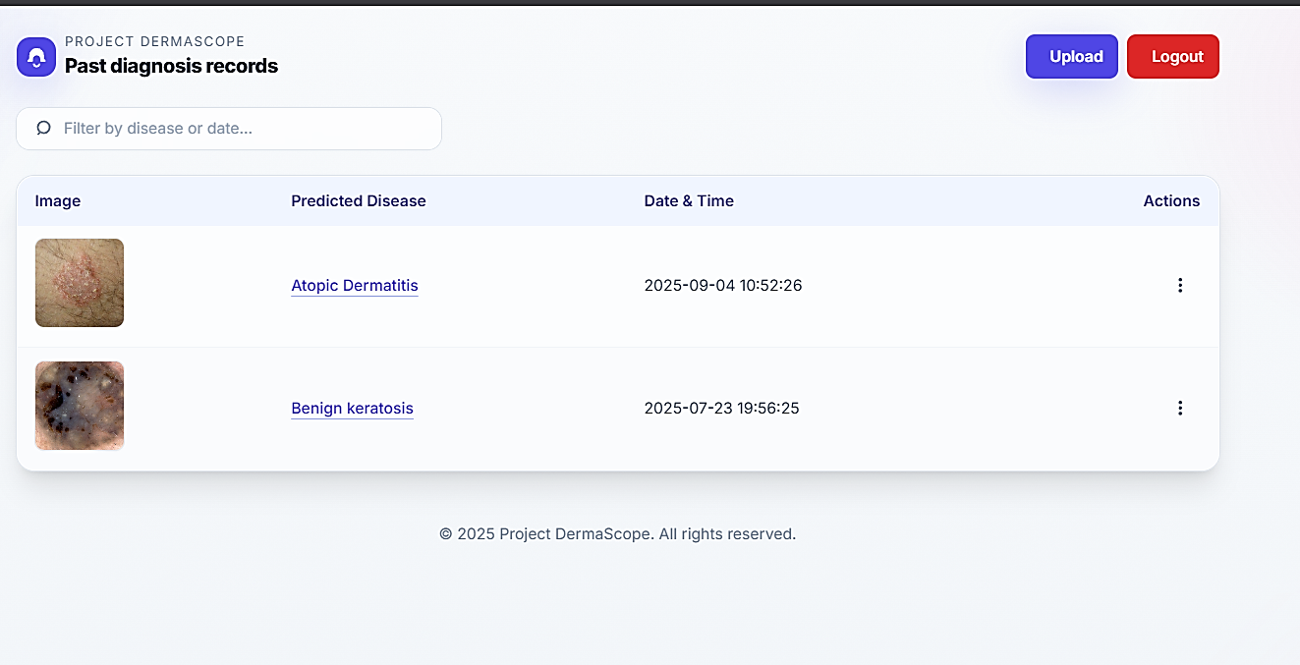

**APPENDIX D Past Records Page**

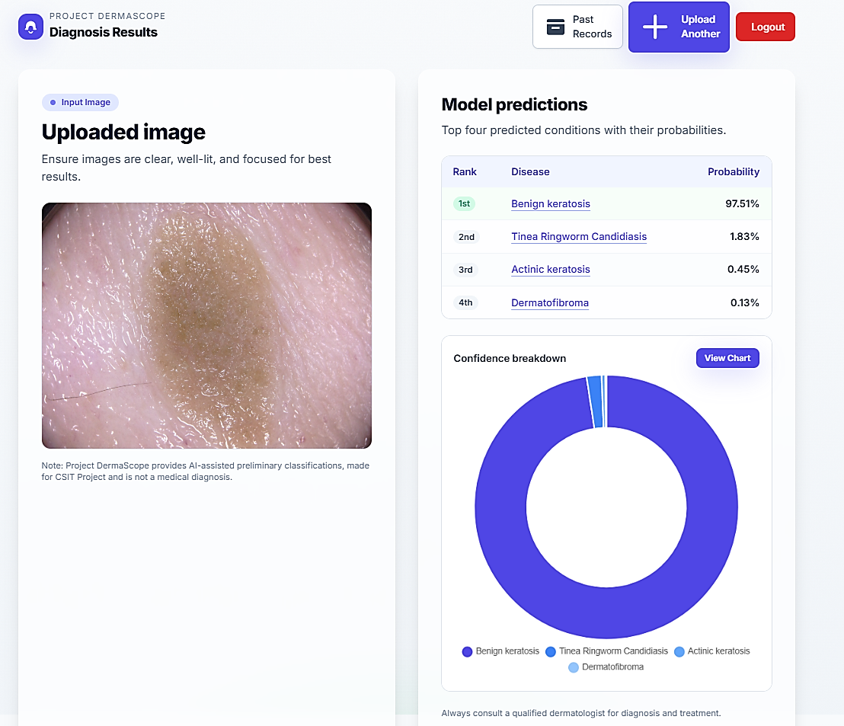

**APPENDIX E Result Page**

